Concept of Operations for the AFSCME Enterprise Application
Architecture, Practices and Responsibilities

Purpose of this document
The purpose of this document if to outline how the Enterprise Application system will be operated and maintained after acceptance testing of Release 1. The Enterprise Application system consists of :
- hardware
- software
- network
- security and
- automated and manual procedures for operating the system
AFSCME intends to host the production Enterprise Application system in a third party hosting provider and will contract for basic support services from the hosting provider. The operation and maintenance practices and tasks not performed by the hosting vendor should be documented.

Acceptance of Release 1 is the key milestone where AFSCME assumes responsibility for operating and maintaining the Enterprise Application system This document records the high level tasks required to operate the Enterprise Application after Release 1 is accepted.
This document does not record detailed task procedures.

The Concept of Operations diagram

For the following discussions, please refer to the Concept of Operations Diagram

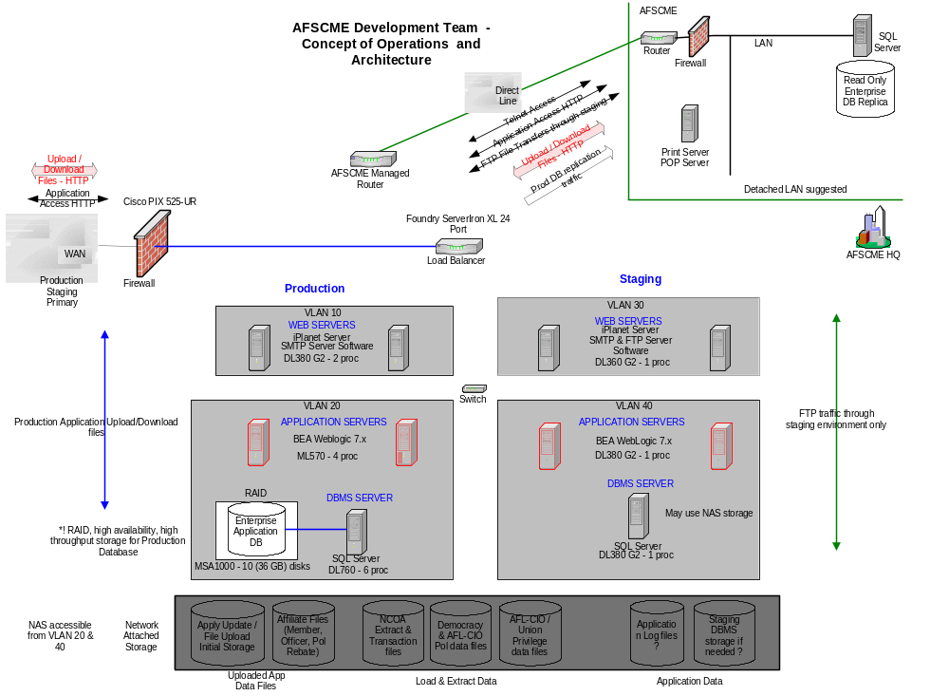

Architecture
The section describes the key aspects of the architecture that affect the Concept of Operations

Practices for performing tasks

DBMS Operation and Management activities
Staging:
Through remote access services(e.g. PC AnyWhere) to the Staging DBMS Server
Production:
Through remote access services to the production server, however, based on hosting support level, may be limited to the SQL Server Enterprise Manager application on that server.

DBMS data extraction and DBMS table loading
Data extraction from the production enterprise(e.g. extract data for NCOA, AFL-CIO Union Privilege files):
Remote access to server which has access to Enterprise Manager console with connection to Production Database Server. Invoke DTS job, or other extraction job to network attached storage(NAS) to a specified directory. File names will be generated by formula. Make accessible to Staging environment FTP server. Download to AFSCME International HQ from FTP Server.
Table Loading in the production environment:
Upload file to Staging environment FTP server. Remote access to staging server to download file to NAS to specified directory. If not a scheduled, periodic load, or if accompanied by database and/or software changes, the data or data and modifications will be first loaded into the staging environment and tested. Otherwise, remote access to Enterprise Manager or other SQL Server client tool with access to production DBMS server to invoke DTS job or other batch load.

Data Extraction for reports/mail files via the AFSCME ‘Print’ Queue
The Enterprise Application creates a file with the data for the report which is then attached to a SMTP message(email) and sent to the AFSCME email server address which serves as the AFSCME ‘Print’ Queue. An AFSCME operator access the email account, and saves the attachment on a workstation or server within the AFSCME LAN. The operator will then copy the file to the appropriate media or print on the appropriate printer.

AFSCME Print Queue
AFSCME is responsible for acquiring, configuring and operating the AFSCME print queue. The AFSCME print queue is designed to be an email account on an AFSCME mail server. An AFSCME operator will review the print queue periodically to respond to the ‘print/media copy’ tasks in the print queue and deleting emails corresponding to completed tasks.

Data Extraction for Save As/File Download functionality
Examples are files that are downloaded to client workstations via this functionality Affiliate Member Enhanced files, PAC module Save As for reports and mail files and any other application function that supports Save As functionality.
The Enterprise Application retrieves the data required. An HTTP response is formulated with a MIME Header Type of attachment and returned to the browser. No AFSCME operation tasks are required for this functionality.

Application File Uploads (mostly for Apply Update related functionality)
Examples of Application Files for upload include Affiliate Member, Officer and Political Rebate upload files and Contributor update files.
The user uses the Enterprise Application to initiate the file upload. Successful file uploads are stored on the NAS in the ‘Apply Update/File Upload’ initial storage area (i.e. a specific directory within the NAS). Other Enterprise Application functions will read the stored files, validate and copy to appropriate directories, especially for ‘Apply Update’ functionality. Finally, Enterprise Application functions will read the files and apply the data in the files to the DBMS.

STAT/PCT Data Extract and Upload
AFSCME will extract via DTS/batch or query/report, the Membership counts they need for STAT. If extracted directly from the production OLTP DBMS, the file will be created on the NAS, accessed from the staging environment and downloaded to AFSCME via the FTP server. If extracted via a report, the file can be sent to the AFSCME print queue and accessed through that mechanism.

For uploading STAT/PCT information back into the Enterprise Application, AFSCME will upload the file via the FTP server in the staging environment and download the file into the NAS. An AFSCME operator will then execute a DTS or batch operation to apply the data to the Enterprise database.

Maintenance of Enterprise Application Software
This section describes the concept of operation concerns maintenance of the Enterprise Application after the application is turned over to AFSCME (currently this milestone is acceptance of release 1). AFSCME will develop and test modifications to the Enterprise Application in the development & testing environments. Once a release candidate build has passed system testing, AFSCME will promote the build to the staging environment (including all database changes) and will perform checkout testing in the staging environment. Once the software in the staging environment is ready for release into production, AFSCME will coordinate with the hosting provider to promote the release into the production environment and to make the release available to the Enterprise Application user community.

Configuration Management of the Enterprise Application
This section describes Configuration Management of the Enterprise Application after the application is turned over to AFSCME. AFSCME will configuration manage the Enterprise Application software in accordance with its own Configuration Management plans. The Configuration Management plans and procedures used by AT&T in the initial development of the Enterprise Application will be available to AFSCME.

Configuration Management, operation and maintenance of the Enterprise Application Environments
Currently, four environments are planned for the AFSCME Enterprise Application:
- Development
- Test
- Staging
- Production
These environments are initially specified by AT&T based on AFSCME’s requirements. AT&T will install and maintain the development and test environments until these environments are turned over to AFSCME. Once the development and test environments are turned over to AFSCME, AFSCME will assume responsibility for the configuration, maintenance and operation of these environments. AFSCME is responsible for contracting with their choice of hosting provider for the establishment and operation of the Staging and Production environments. . AT&T will initially install the Enterprise Application (including infrastructure software if needed) in the procured hosted environment and will operate the Enterprise Application until release 1 of the Enterprise Application is accepted. At that point AFSCME is responsible for the Configuration Management, operation and maintenance of the Enterprise Application Staging and Production environments.

Responsibilities and tasks

DBMS Operation and Management activities
AFSCME is responsible for all good practice Database Administration tasks. AFSCME IT will decide which DBA task will be performed and at what levels and periodicity. Examples of DBA tasks which should be considered by AFSCME:
- Running DBCC
- Running Update Statistics
- Monitoring DBMS performance statistics and index schemes
- DBMS backup and restores

DBMS data extraction and DBMS table loading to support the Enterprise Application
AFSCME will be responsible for all data extracts and table loading not covered by another mechanism. This includes:
- Periodically re-loading new data into the Com_Democracy_Ranged table
- Periodically removing the existing records and re-loading new data into the Com_AFL_CIO_COPE table
- Extracting affiliate member counts needed for the current STAT/PCT application
- Loading data output from the current STAT/PCT application into the Aff_Fin_Info table
- Extracting NCOA data in accordance with the vendor file layout and sending this data to the Vendor
- Removing any existing rows and loading NCOA Transactions received from the NCOA vendor into the NCOA_Transactions table
- Periodically reloading or applying updates to the COM_ZipCityState_Vld

NCOA transaction related task
Once the NCOA transactions from the latest NCOA run are loaded into the database, an AFSCME operator is responsible for initiating the NCOA processing through an application provided action. This is covered in an application use case but noted here since this task sits in between two NCOA operator tasks.

Maintenance of DBMS tables
AFSCME is responsible for the periodic and volume related maintenance of DBMS tables that the Enterprise Application depends on. These tables include:
- AUP_Queue_Mgmt – rows in AUP_Queue_Mgmt should be deleted over time in coordination with archiving the associated files. The queue will only show files that meet a specified limit on their date, however, the entries to old files will remain until deleted.
- Deleting records corresponding to operations that mark records for deletion

Maintenance of Application related files
Certain file will reside within the production and staging environments as part of operating the Enterprise Application system. In order to manage and reuse disk space, files that are no longer needed may be archived(transferred to alternate storage and then removed) or deleted. AFSCME is responsible for these operations for a number of files. These files include:
- Files used to load data into the Enterprise Application database
- Files that hold data extracted from the Enterprise Application (that are stored within the production or staging environments)
- Files that are imported through the import functionality of the Enterprise Application. These files include:
  - Affiliate Member Update files
  - Affiliate Officer Update files
  - Affiliate Rebate files
  - Participation files

Management and maintenance of SQL Server scheduled tasks
Certain processing within the system will be scheduled through the SQL Server scheduler. AFSCME is responsible for managing these scheduled tasks, including reassigning different times and periods for these tasks as needed. Typically, the tasks are:
- stored procedures or some other batch oriented process,
- scheduled nightly
- and access a control table which indicates whether the task needs to be run.
Current SQL Server batch processes include:
- NCOA processing
- Affiliate Mass Change processing (certain actions)

AFSCME Data Subscriptions
AFSCME will maintain subscriptions to data needed for the Enterprise Application. This data currently includes:
- NCOA data and services
- Zip, City, State validation and lookup data

